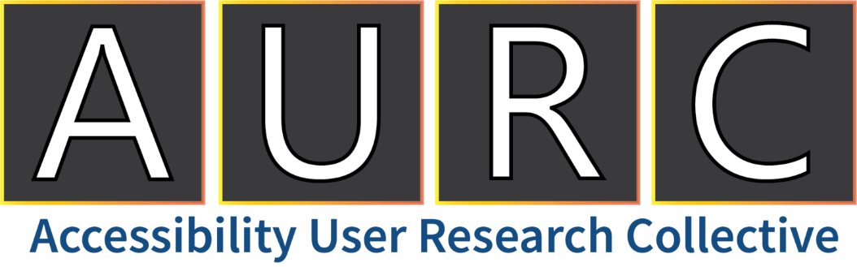

Spring 2023
News, Events, and Resources

Happy Spring, AURC Family!

This new season presents new research opportunities with the Accessibility User Research Collective. We are excited to work with you all to test new developments in technology, gather your insights, and make products and services more accessible for all!
The Accessibility User Research Collective is a national network of people with diverse backgrounds, insights, and needs for accessible technology.
Thank you for being a valued member of the AURC community!

Skip to a Section:
Upcoming Opportunities 2
News For You 2
Member Spotlight 3
AURC Program Updates 4
Recently Completed Projects 4
Additional Accessibility Resources 5

Upcoming Opportunities
- For upcoming AURC Studies: Check out our website for the latest updates in study recruitment!
Open Studies — Accessibility User Research Collective

- Do you have limited or impaired hand function? Shepherd Center’s Assistive Technology Center wants to hear from you about Activities of Daily Living (ADLs) and adaptive equipment. This survey should take no longer than 10 minutes to complete:
https://www.surveymonkey.com/r/ADLs_DeodorantHolder *
  - *This is a voluntary survey; there is no compensation. All feedback will remain anonymous and will be used to understand the needs of adaptive equipment for ADLs.

News For You
- Global Accessibility Awareness Day (GAAD) is May 19th! GAAD is a day for thinking and learning about digital access and inclusion for the more than One Billion people in the world with disabilities/impairments. Find events near you or attend virtually here: Global Accessibility Awareness Day 2023
- Free ASL1 and ASL2 classes: Are you interested in learning American Sign Language? The Oklahoma School for the Deaf is hosting free, online, self-paced classes! Learn more about it here: OSD ASL Courses . These classes are only available until July 31st!
- Are you blind and use an Android device? Are you thinking about making the switch to an Android device? We have a fantastic resource for you! Visit Blind Android Users to listen to informative podcasts on debunking the myth that Android isn’t usable by the blind! Visit the website to sign up for the email list, listen to the podcast, and ask your own questions regarding accessibility of Android devices!
- Mattel releases Barbie doll with Down syndrome: In efforts to increase inclusivity and representation, Barbie recently partnered with the National Down Syndrome Society in the United States to design a doll with Down syndrome. With this doll, they hope to “counter social stigma through play.” Read more and check out the doll here: Barbie with Down syndrome
- In April, we observed:
  - Limb Loss Awareness Month
  - World Autism Awareness Day (April 2nd)
  - World Health Day (April 7th)
- Coming up, we have:
  - National Arthritis Month (May)
  - Mental Health Month (May)
  - Alzheimer’s and Brain Awareness Month (June)
  - PTSD Awareness Month (June)
  - Migraine and Headache Awareness Month (June)
  - National Cancer Survivors Day (June 5th)
  - Autistic Pride Day (June 18th)

- 2023 Calendar of Disability-Related Dates – Want to stay up to date on all disability-related dates this year? Our friends at Disability:IN have the 2023 calendar on their website: Disability:IN 2023 Calendar

Member Spotlight
Keith Delk
As a graduate student in Accessible Human Centered Computing at Gallaudet University, Keith Delk's passion for creating accessible experiences and staying ahead of today's rapidly changing technology landscape led him to become a product designer for gosign.ai, the first chatbot for the deaf community. Additionally, he serves as the Innovation and Accessible Technology Director for Accessibility Global (www.accessibilityglobal.com). In his spare time, he manages and creates content for Handy Resources (www.instagram.com/handy_resources), showcasing the incredible world of modern access technology. These initiatives embody his values of bringing accessible and modern experiences to everyone.

Calling all content creators! Many of our AURC members are using social media platforms to raise awareness and share information related to disability and accessibility. If you are a content creator and would like to be featured in the Member Spotlight in our next newsletter, please send us an email: Accessibility_Research_Collective@shepherd.org.

AURC Program Updates

Recently Completed Projects

- Accessibility of smart homes devices – 20 adults across all disability groups recently shared their thoughts on the accessibility of smart home devices. These participants talked about which smart home devices they own, their setup, their smart home apps, and accessibility pain points. They also provided input on the different ways in which smart home devices can be used to help people with disabilities and their family members with daily household tasks. The feedback from this study will be used to help inform the design of accessible smart home devices.
- Accessibility of a social media app – 10 blind participants tested out a social media app on their mobile phones. In this study, participants completed several tasks on the mobile app, focusing specifically on a feature that informs the user about who has engaged with the user’s posts. They identified what worked well within this feature and provided areas of improvement for screen reader integration. The results of this study will be used to improve the experience of those who use screen readers to access the mobile app.
- Exam Accommodations Website Prototype – 8 participants with varying disabilities who require accommodations when taking an assessment or certification exam tested a prototype of an upcoming accommodations request website. Participants walked through a simulation of gathering information that they would need to complete an accommodation request and then requesting those accommodations. The designers of this upcoming website are using the feedback provided in this study to ensure that the accommodations request process is simple and easy to follow!
- Public Green Spaces and Parks Survey – 336 AURC members completed our survey on parks and spending time outside. Across all disability groups, members said that spending time outdoors is good for their mental and physical health. Members are avid park users as over half go to parks at least once a month. Findings from this study will help inform policies to achieve improved access to parks.
Thank you, again, to all who have taken the time to participate in these studies. We deeply appreciate your efforts!

Additional Accessibility Resources
We are happy to share resources to help you learn more about accessibility resources and services.
- You can always stay connected on Twitter. Check out the following Twitter accounts to stay connected! @MSFTEnable, @IncTechLab, and @AURC_Shepherd
Spread the word about the AURC! Share this newsletter and tell friends to visit us, check out the latest open studies, and join the collective: https://accessibilityuserresearchcollective.org/

Thank you!

Delaney Cowart
Program Lead and User Experience Researcher
Accessibility User Research Collective

Delaney.Cowart@Shepherd.org
https://accessibilityuserresearchcollective.org/

