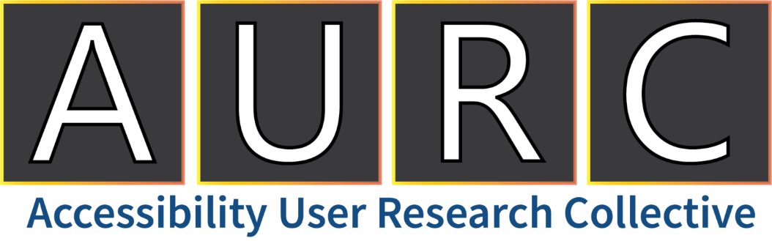

Winter 2023
News, Events, and Resources

Hello, AURC Family!

Happy 2023! This new year presents new research opportunities with the Accessibility User Research Collective. We are excited to work with you all this year to test new developments in technology, gather your insights, and make products and services more accessible for all!
The Accessibility User Research Collective is a national network of people with diverse backgrounds, insights, and needs for accessible technology.
Thank you for being a valued member of the AURC community.

Skip to a Section:
News For You 2
Member Spotlights 3
AURC Program Updates 4
Upcoming Studies 4
Recently Completed Projects 4
Additional Accessibility Resources 5

News For You
- JanSport Releases Adaptive Bag and Backpack Collection – These products were codesigned alongside the disability community and come in a variety of bags and backpacks that fit power wheelchairs, manual wheelchairs, walkers, and mobility scooters. They are highly customizable to ensure a snug fit on any mobility aid, with no loose or dragging straps. Read more about this new line from JanSport: Forbes: JanSport Launches Adaptive Bags

- Winter includes…
  - Glaucoma Awareness Month (January) – In the United States, around 3 million people have glaucoma. Experts estimate that up to half of that number do not even realize that they are affected. To learn more about glaucoma and the importance of regular eye exams, check out this page from the Glaucoma Research Foundation: Glaucoma Awareness Month
  - World Braille Day (January 4th) – In early January, we observed World Braille Day. Braille is a tactile representation of the alphabet and numbers using six dots raised in various combinations to represent each letter and number. It even has representations for musical, mathematical, and scientific symbols. UN: World Braille Day
  - Rheumatoid Arthritis Awareness Day (February 2nd) – Rheumatoid arthritis (RA) is an autoimmune and inflammatory disease that causes painful swelling in joints and, in severe cases, internal organs. One and a half million people in the United States live with this condition, with over 70% being women. CureArthritis.Org
  - Coming in March 2023:
    - Developmental Disabilities Awareness Month
    - Cerebral Palsy Awareness Month
    - Multiple Sclerosis Awareness Month
    - Brain Injury Awareness Month
    - International Wheelchair Day (March 1st)
    - World Down Syndrome Day (March 21st)
    - Purple Day for Epilepsy (March 26th)

- 2023 Calendar of Disability-Related Dates – Want to stay up to date on all disability-related dates this year? Our friends at Disability:IN have released their 2023 calendar: Disability:IN 2023 Calendar

Member Spotlights
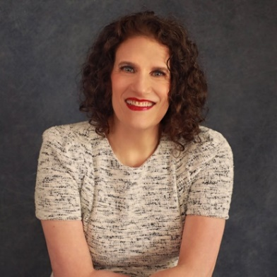
Meryl Evans was born hearing-free or, in medical terms, profoundly deaf. Her speaking topics and content primarily focus on educating people about accessibility and folks with disabilities.
  - LinkedIn: Meryl Evans LinkedIn
  - Website and Blog: Meryl.Net
  - Twitter: @MerylKEvans

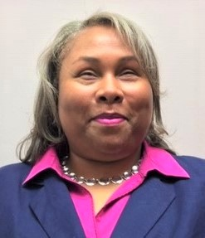
Empish J. Thomas is a freelance writer, blogger, and accessibility consultant. She writes human interest and lifestyle pieces along with blog posts about vision loss. She was a diligent and long-time career columnist for 17 years with Dialogue Magazine. She also ventured into broadcast journalism by hosting and producing a radio show called “Eye on Blindness” with the Georgia Radio Reading Service.
- LinkedIn: Empish Thomas LinkedIn
- Personal Website and Blog: EmpishThomas.com

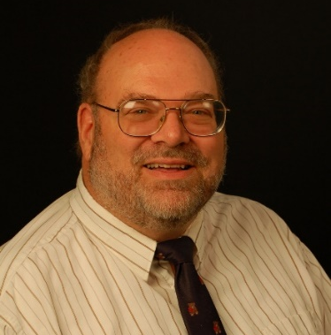
Tim Vermande is a Communication Specialist for the Disability Ministries Committee of the United Methodist Church and the Deaf and Hard-of-Hearing Ministries Committee of the General Board of Global Missions, UMC. Tim works to share issues of concern with a variety of disability and hearing-related groups. Through his management of websites and social media accounts, he strives to educate about ableism and audism, share best practices for accessibility, promote inclusion, and advise of events.
- Ministry Websites:
  - United Methodist Committee on Deaf and Hard of Hearing Ministries
  - Disability Ministries of The United Methodist Church
- Personal Website and Blog: The Flying Kitty Monster

Calling all content creators! Many of our AURC members are using social media platforms to raise awareness and share information related to disability and accessibility. If you are a content creator and would like to be featured in the Member Spotlight in our next newsletter, please send us an email: Accessibility_Research_Collective@shepherd.org.

AURC Program Updates

Upcoming Studies
- Details of upcoming studies will be on the AURC website very soon. Check back in with this link if you are interested: AURC Open Studies

Recently Completed Projects
- Public Green Spaces and Parks Survey – 336 AURC members completed our survey on parks and spending time outside. Across all disability groups, members said that spending time outdoors is good for their mental and physical health. Members are avid park users as over half go to parks at least once a month. Findings from this study will help inform policies to achieve improved access to parks.
- Accessibility of UX Research Methods – 20 adults across all disability groups recently shared their thoughts on the accessibility of different methods of user experience (UX) research, such as interviews, surveys, and focus groups. Other factors of research, including inclusive language, stipends, scheduling flexibility, transportation, and time commitment were also discussed. The results from this study will help us improve our practices as an accessibility UX research shop!
- Accessibility of Restaurant Kiosk – 10 participants with low vision recently visited a restaurant in the Atlanta area and tested the self-ordering kiosk and its accessibility features. They completed several tasks on the kiosk, and then gave their feedback what went well and what needed improvement. The results of this study will inform developers as they modify and improve the system for folks with low vision.
- Smart TV Accessibility Features – 7 participants from different disability groups recently came to our lab at Shepherd Center in Atlanta and tested the accessibility features of a smart TV.
- Exam Accommodations Policies – A recent survey and interview study assessed the opinions of people with disabilities on what documentation should be required in order to receive exam accommodations. 50 people from different disability groups completed the survey, and 8 of those people participated in an in-depth interview. The results of this study will inform the exam provider on how to help people with disabilities who may not have documentation of their disability.
Thank you, again, to all who have taken the time to participate in these studies. We deeply appreciate your efforts!

Additional Accessibility Resources
We are happy to share resources to help you learn more about accessibility resources and services.
- You can always stay connected on Twitter. Check out the following Twitter accounts to stay connected! @MSFTEnable, @IncTechLab, and @AURC_Shepherd
Spread the word about the AURC! Tell friends to visit us, check out the latest open studies, and join the collective: https://accessibilityuserresearchcollective.org/

Thank you!
Delaney Cowart
Program Lead and User Experience Researcher
Accessibility User Research Collective

Delaney.Cowart@Shepherd.org
https://accessibilityuserresearchcollective.org/

